CONTINUOUS ENGAGEMENT STRATEGIES
Change Management Toolkit - Resource
Phase | 3. Reinforce and evaluate the change
Step | 3. Reinforce the Change
Revision date | April 18, 2024
Contents
Purpose 1
Strategies 2
Hook new users 2
Gradually introduce new and exciting features 3
Encourage continuous learning 4
Utilise Borealis features to trigger engagement. 6
Make it a game 7

Purpose
In today’s fast-paced digital landscape, maintaining continuous engagement with software users is crucial for maximizing productivity and ensuring long-term success. This document outlines comprehensive strategies designed to keep users hooked, seamlessly introduce new features, and foster a culture of continuous learning within our organization. By implementing these engagement techniques, we aim to enhance user satisfaction, drive adoption rates, and ultimately achieve your business objectives. Let’s explore how we can create a dynamic and engaging user experience that keeps users team motivated and proficient with a platform.
Strategies
Hook new users
Description | Your first chance at boosting user engagement with Borealis comes when users are first introduced to the system. Most of your users will be seeing Borealis for the first time and they may already be resistant for reasons you’ve identified in your engagement planning.  During system onboarding, you have the opportunity to generate interest in the capabilities and functionality of the system by providing users with quick wins and demonstrating how easy it can be to get value from Borealis.
Why does it work? | This chart showing retention rates for Android apps illustrates that user engagement is highest in the first week of usage.  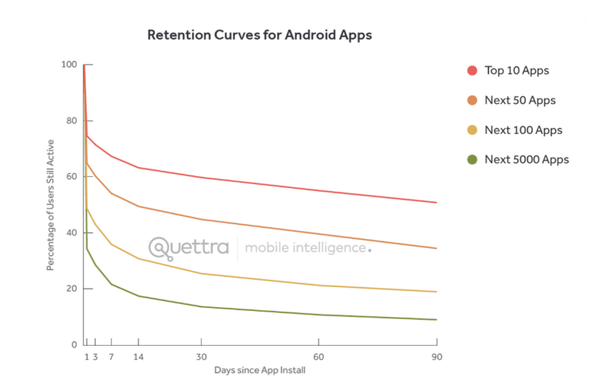  Grabbing peoples’ attention and demonstrating value early in the onboarding process increases the likelihood of users staying engaged past that initial period.
Tactics | - Make sure they know how to log to the platform.  - Use an onboarding checklist that has new users walk through some basic tasks in Borealis by themself. This serves two purposes in that it helps them see the system is easy to use and also gives them the tangible satisfaction of ticking things off in a list.  - List Example:  Log to Borealis and consult all sections of the ‘welcome page’:  - Identify your superusers, make sure you know how to contact them  - follow the steps in the ‘get started’ section  - Watch introduction videos  Perform your first actions in Borealis:  - Create a communication from the Oulook/G-mail add-in  - Create communication from the Mobile App  - Create a task for yourself  - Ensure that they have a clear understanding of:  - The tasks they are expected to perform in Borealis  - The outputs they will get from it (record consultation, reports)  - Make sure they are added to the ‘Scheduled reports’ intended for their team.  - Add them to the relevant e-mail notifications  - Set up a buddy system, where a new user is paired with a more confident user, giving them a direct line for support when they first start using Borealis.

Gradually introduce new and exciting features
Description | Borealis is a very powerful tool with many features. However, when people are first learning to use the system, it’s best to limit the amount of functionality that is immediately revealed. This way users can gradually build confidence using the system.  But once users are getting more comfortable in the system, they will be ready to take in more information.
Why does it work? | Cognitive load theory tells us that working (or short-term) memory has a limited capacity and if we push too much new information on learners, they won’t be able to retain it.  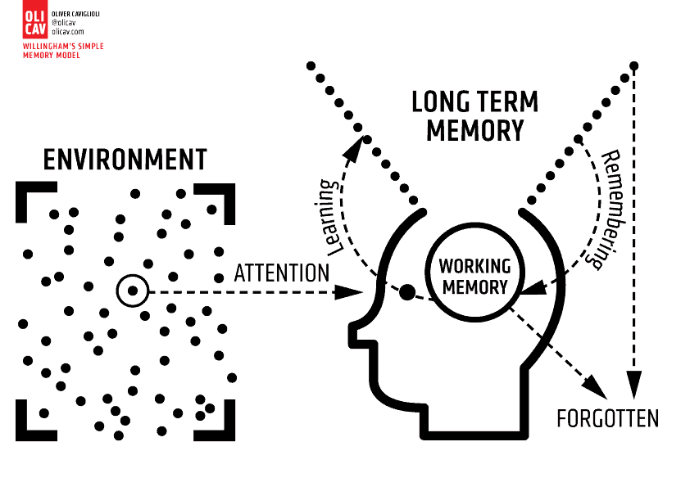  If wait until some of the new learning has moved into long term memory, users will be more likely to retain and use that knowledge!
Tactics | - Use tooltips and descriptions in Borealis. This will remind users the process, function or definition of the field they are looking at in real-time as they are working in the system.  - Set up an e-newsletter to users that regularly shares new features, tips & tricks, updates, etc. Refer to the resource “Borealis Tips & Tricks” for some ‘ready to share’ content.  - Use meeting icebreakers as an opportunity to share tidbits about Borealis or educate on new features.

Encourage continuous learning
Description | According to studies, people lose roughly 50% of new learning within an hour and 70% after 1 day. Obviously, engagement with Borealis will drop off noticeably as people forget what they have just been taught.  Retention continues to drop off over time without intentional interventions. Some users may seek out more information on their own, while others may need to be fed that learning in a more deliberate or intentional way.
Why does it work? | 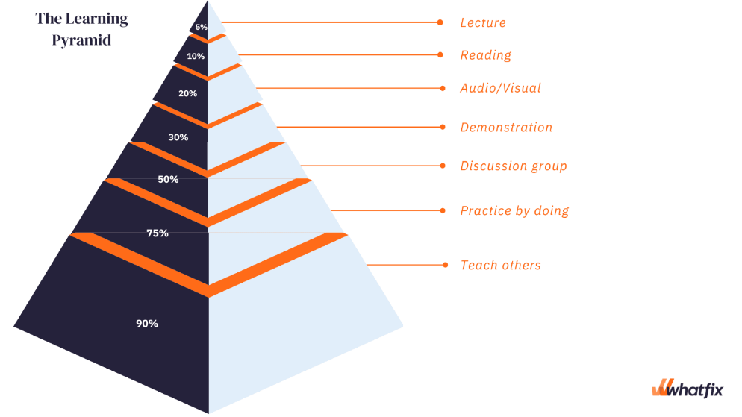  This illustrates that people retain information much more when the way that information is delivered is more interactive and hands on. Your initial Borealis training will include some practice in the system, but without encouragement to continue that practice and reinforcement with other delivery methods, users are likely to quickly forget how to use the system.
Tactics | - Deploy a spaced-learning program: build in some short periods for people to absorb information and for self-guided practice, but then bring users back to repeat the key parts of the training to help with retention and offer the chance to ask questions.  - Consider providing additional training within 1 month of initial training and then refresher training every 3 months  - Host regular drop-in working sessions for people to bring questions and tackle challenges they have encountered in using Borealis  - Have experimented users train newer users

Utilize Borealis features to trigger engagement.
Description | New systems can be forgotten if they are not built into people’s day-to-day workflow. Get people to engage in using Borealis by reaching them through other platforms they are using every day.  Borealis has built-in features that can support improved user engagement and provide super users with important data to help develop targeted engagement solutions.
Why does it work? | Sometimes low engagement with new systems like Borealis is simply rooted in unfamiliarity. People tend to develop preferences for things (programs) that are known to them. This is called the mere exposure effect or the familiarity principle.    By linking the new system (Borealis) with a more familiar one (like email), you can prompt users to move into the new system and build that familiarity slowly.
Tactics | - Set up email notifications from Borealis to alert users to new content (tasks, engagement plans, grievances, issues, etc.), approaching planned events and passed deadlines.  - Create scheduled reports so that valuable data from Borealis is shared with key users in an accessible and visually appealing way.  - Track user activity using analytics to understand which parts of the system are being underutilised and identify user groups that may require more support.

Make it a game
Description | Gamification, or the introduction of game design elements and into non-game contexts, has been shown to increase engagement, retention and performance.  The point of gamification is to inspire users to engage with the content. Especially with tasks that are not enjoyable, such as data quality management.
Why does it work? | There are many theories about why gamification supports learning and engagement but mostly it is because it makes things more fun! Gamification generates motivation to get through basic or repetitive tasks because it provides a reward in the form of dopamine.  
Tactics | - Set up a friendly competition between departments  - Develop a game performance measurement system of levels, badges, titles and podiums so users can always be striving to hit that next goal.  - Recognize performance with prizes  - See our guide on Gamification for more tips on how to implement in your organization.

