GAMIFICATION GUIDE
Change Management Toolkit- Resource
Phase | 3. Reinforce and evaluate the change
Step | 3. Reinforce the change
Revision date | August 9, 2024
Contents
1. Understand Gamification 2
1.1 What is Gamification? 2
1.2 How Gamification can help your organization 2
1.3 When to use Gamification 2
2. Efficient gamification 2
2.1 What to consider in implementing efficient gamification 3
2.1.1 Choose a Specific Subject/Knowing the Problem 3
2.1.2 Determine the duration and the frequency 3
2.1.3 Understand each type of gamer 3
2.1.4 Choose your format: Team vs. Individual Games 4
2.1.5 Determine the measurement system you will use 5
2.1.6 Determine the price 5
2.2 Best Practices and Potential Challenges 6
3. Steps to implement Gamification 6
3.1 Define Clear Data Quality Metrics 7
3.2 Determine your game aspects 7
3.3 Operationalize the game 7
3.4 Entertain the game 8
3.5 Celebrate achievements 8
4. Appendix 9

- Understand Gamification
  - What is Gamification?
Gamification is the process of using game mechanics, elements, and principles and applying them to non-game contexts to better engage users. The goal of gamification is to inspire users to engage with the content, especially with tasks that are not enjoyable, such as data quality management.
  - How Gamification can help your organization
Gamification can help your organization to:

  - When to use Gamification
Gamification works best when the people you want to engage are not very interested, are unmotivated, or are dealing with tricky tasks. You can use it in different environments, including educational and professional. The important thing is to make sure gamification matches up with what your organization wants to achieve.
- Efficient gamification
  - What to consider in implementing efficient gamification
    - Choose a Specific Subject/Knowing the Problem
Figuring out what is causing the problems and how to improve things will guide you in picking the right topic for gamification. Listening to users and analyzing data are really important in grasping the issue and creating gamification that actually works.
    - Determine the duration and the frequency
The duration of gamification largely depends on the complexity of the task and the objectives to be achieved. Short-term gamification can be used for quick engagement boosts or training sessions, while long-term gamification can be employed for continuous learning or sustained behavioral change.
Recommendation
If you want to gamify a specific topic, one in which you do not have a lot of metrics to play with, a few training sessions to do and not much data to create or modify, we suggest short term gamification (from a day to a few weeks).
If you want to gamify a large-scale subject, one in which there is more data involve, many subcategories to take into consideration, more data management and information to learn or consider, we suggest long term Gamification (a few to many months).

The frequency of gamification will depend on the needs of the company and the type of game you are implementing. It is important to balance properly the time and energy spent on gamification to keep your team motivated and excited about the game.
Recommendation
We would recommend taking breaks after a game depending on its duration and the energy of your team. Breaks length should be proportional to the game duration.

    - Understand each type of gamer
When you implement gamification in your business, it is important that all types of gamers have something that connects them to the game. Here are the different types of gamers.
- Explorers: Explorers are motivated by the discovery of new content, secrets and hidden information within the game. Explorers are often driven by curiosity and the thrill of finding new things.
- Achievers: Achievers are focused on accomplishing goals, reaching high levels, obtaining rewards, and demonstrating their success. Achievers are motivated by a sense of progression and personal accomplishment.
- Socializers: Socializers are centered around interactions with other players. Socializers enjoy connecting with others, participating in group activities, and building lasting relationships.
- Killers: Killers are competitive and seek to dominate other players. They are motivated by challenge, competition, and the thrill of defeating opponents.
    - Choose your format: Team vs. Individual Games
Choosing between team-based or individual gamification depends on the context and the desired outcomes. Team games promote collaboration, foster a sense of belonging, and encourage social interactions. They are ideal for enhancing teamwork, competition, and collective achievements. On the other hand, individual games focus on personal growth, individual challenges, and customized experiences.
Recommendation
Team: We recommend using teams when the task requires diverse skills and expertise that individuals alone may not possess, and when collaboration, shared responsibilities, and collective decision-making are essential for achieving the best outcomes.
Individual: We recommend completing tasks individually when the game requires deep focus, personal expertise, or a high level of creativity, allowing for dedicated attention and minimizing potential distractions from a group setting.

    - Determine the measurement system you will use
Levels, badges, titles and podiums are fundamental game elements that provide a sense of accomplishment and recognition to participants.
- Points: Using points is the easiest way to measure and quantify the progress of the individuals. You can easily use points and another measurement system to motivate the players. In Borealis, the number of actions is very useful to use as points.
- Levels: Signify progression and proficiency, motivating users to achieve higher ranks and unlock new challenges.
- Badges: Serve as visual rewards for completing specific tasks or demonstrating particular skills, fostering a feeling of achievement.
- Titles: Can be used to designate expertise or leadership roles, promoting healthy competition and status recognition within the gamified environment.
- Podiums: Podiums are used in a company to showcase top performers and acknowledge outstanding achievements. They can be used in all types of game.
Recommendation
Levels: Use level on a larger scale gamification in which people have many metrics to play with and compete individually or in teams.
Badge and titles: Use badges and titles when the subject is more specific and for individual competition.

    - Determine the price
In gamification, it is important to have a prize to motivate your team to participate. There are various ways you can determine the winner. Of course, you can award a prize to the best performer, but you also need to ensure that everyone or each team has an equal chance of winning. That's why it is crucial to create teams thoughtfully. Here are some examples of how to award a prize:
- Conduct a prize draw among the 5 best performers
- Organize a prize draw for each level achieved; when an individual reaches a level, they will be included in the draw for that specific level
- Award the prize to the person who has shown the most improvement
- The 'Employee of the Month' award, determined by colleagues or supervisors
- Recognition by the manager in front of the team
- Recognition post on LinkedIn
- Coffee or lunch with an inspiring superior
Recommendation
We recommend adjusting the value of the prize with the duration of the game.

  - Best Practices and Potential Challenges

- Steps to implement Gamification
Here is a step-by-step guide on how to implement gamification in a business for example if you aim at improving data quality:

  - Define Clear Data Quality Metrics
- Identify the process where data quality is lacking
- Choose the specific data you want to gamify
- Set an achievable goal
- Create a report that will show all the data related to your game
- Develop widgets to add to the reports, here are some examples:
- The current status of your data quality
- The data that needs to be worked on
- The progression (for each individual or for the team)
- The target/goal
- Write down your baseline
- Set-up some automation to congratulate your team when reaching a new level or when the goal is reached
  - Determine your game aspects
- Duration of the game
- The participants
- Individual or group
- The reward system you will use:
  - Award badges or points to employees maintaining high data quality
  - Identify motivating rewards for participation in the gamified system
- Choose a price to motivate the team
  - Operationalize the game
- Present the game
  - How to present Gamification to the team: Before implementing a game to the team, make sure that your employees understand the concept of gamification.
Suggestion: Having a gamification representant
- Having a dedicated person or team in charge of gamification within an organization is crucial for maximizing its effectiveness. This specialized oversight ensures that gamification strategies align with broader business goals, maintaining consistency and relevance. These experts can continuously analyze user engagement data, adapt game mechanics, and design tailored experiences, enhancing motivation and participation. Their role empowers the organization to create immersive and impactful gamified solutions that drive desired behaviors and outcomes. This person would oversee the planification of the game, explaining it to the group, and would be in charge of the follow-up and the results.

- Launch the contest where employees compete to enhance data quality.

  - Entertain the game
- Deliver motivation words through notifications or progress indicators
- Encourage people to share their points of view on reward participation
  - Celebrate achievements
- Publicly celebrate data quality milestones and achievements
- Recognize individuals and teams who contribute significantly to improving data quality
- Gather feedback: Review how the game went, the progression, what went best and what went worst. What could be improved for the next contest?

- Appendix
Example 1
John, the person in charge of gamification and the superuser of Borealis, will follow the steps (above) to implement gamification in his company.
You can use the last column to enter your comments / notes regarding the implementation of your own gamification.
- Duration: Long term gamification
- Format: Teams
- Subject: Stakeholders
1. Define Clear Data Quality Metrics: |  | Borealis Example | Your gamification
1.1 | Identify the process where data quality is lacking | When people are adding individuals to the system.
1.2 | Choose the specific data you want to gamify | Confirm that following fields are filled in:  - Email address  - Organization  - Language of communication
1.3 | Set an achievable goal | Within 3 months, I want 3000 individuals in Borealis to have an email address, an organization and a language of communication.
1.4 | Create a report that will show all the data related to your game | Name of the report: Individuals data quality (images 1, 2 and 3).
1.5 | Develop widgets to add to the reports | Name of the widgets:  - Individuals without email (image 1)  - Individuals without organization (image 1)  - Individual without language of communication (image 1)  - The teams (A, B, C, D) (image 2)  - The progression for each team (image 3)
1.6 | Write down your baseline | (See image 1)
2. Determine your game aspects
2.1 | Duration of the game | 3 months
2.2 | The participants | Every person who has to enter individuals in Borealis.
2.3 | Individual or group? | Groups (1 group per department)
2.4 | The measurement system you will use | Points: the number of points will equal the number of actions.
2.5 | Choose a price to motivate the team | A draw within the winning team allows one participant to win a gift card.
3. Operationalize the game
3.1 | Present the game | John will present the game during the weekly meeting with all the participants in the game. The reports as well as the instructions will be presented to the team.
3.2 | Launch the contest where employees compete to enhance data quality | The contest will be launched the day after the meeting.
4. Entertain the game
4.1 | Deliver motivation words through notifications, or progress indicators | Emails will be sent weekly to congratulate the team for their efforts and to show their progress. These emails will also contain a note that encourages people to give John feedback about the game. It is important for him to collect positive and negative feedback.
4.2 | Encourage people to share their points of view on reward participation
5. Celebrate achievements
5.1 | Publicly celebrate data quality milestones and achievements | When the game is over, John schedules a meeting to announce the winning team. He will also do the prize draw to announce who will win the gift card. He will announce if the objective as well as the targets have been achieved. Everybody will be congratulated and encouraged to give feedback about the game. The comments will be considered by John for his next gamification game.
5.2 | Recognize individuals and teams who contribute significantly in improving data quality.
5.3 | Gather feedback: Review how the game went, the progression, what went best and what went worst. What can be improved for the next contest?

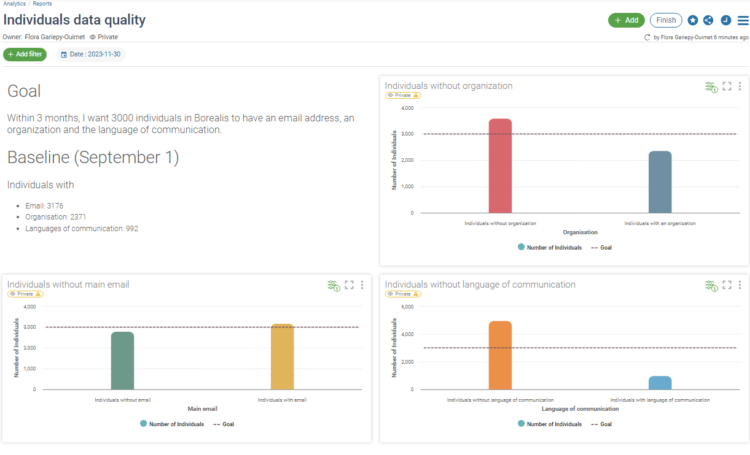
Image 1

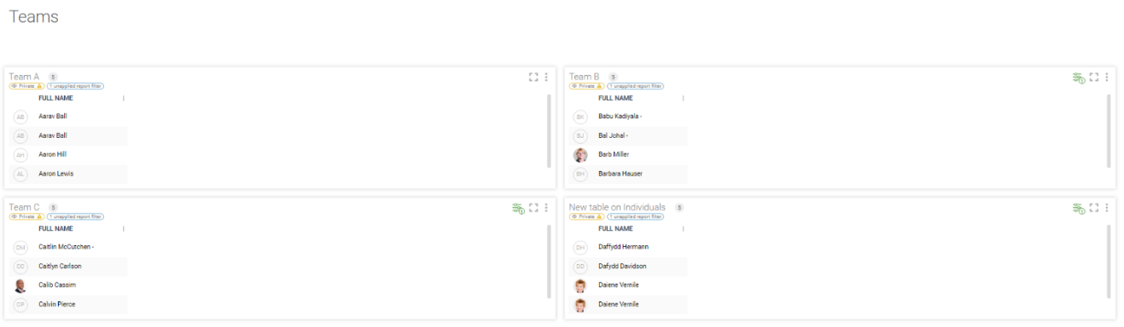
Image 2

Image 3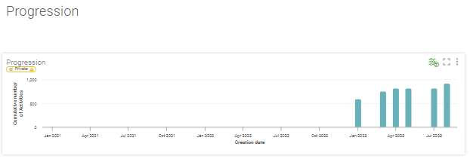

Example 2
TechX customer team use a project management system called Borealis to keep track of all project-related communications, such as emails, calls, and notes exchanged with clients. However, there is a challenge with consistently and accurately entering these communications into the system. As a result, the employees must reach out to the client multiple times for the same issue, thus reducing the staff efficiency and the quality of customer service
- Duration: Short-term gamification
- Format: Individual
- Subject: Communications
Identify the process where data quality is lacking | Communications entry in Borealis via Outlook.
Choose the specific data you want to gamify | The number of communications added in the system.
Duration of the game | 3 weeks
The participants | The customer team
Individual or group? | Individual
The measurement system you will use | Points and levels
Choose a price to motivate the team | A draw for each level reached by the player. Each level has a different price, obviously the harder level gets the best price.

Example 3
TechX Solutions is a technology company that provides various software solutions to their clients. One of their processes involves the marketing team sending important communications to their customers through their "smart communications" module. However, the company has noticed that there are often errors in these communications, including incorrect customer names, outdated information, and formatting issues.
- Duration: Short-term
- Format: Group
- Subject: Smart communications
Identify the process where data quality is lacking | People have difficulties using the module “smart communications”.
Course of the game | During the first hour, there will be a training session animated by John. He will explain to the team how Smart communications work. Then he will separate the team into groups and distribute the instruction sheet to each group (See below). Following the instructions, each group will have the rest of the session to do smart communications.
Duration of the game | 3 hours
The participants | The marketing team
Individual or group? | Groups of 4 or 5 people
The measurement system you will use | The success of smart communications will show the success of the game.
Choose a prize to motivate the team | A badge will be sent to the team that have succeeded in sending their smart communications by email. They can add the badge to their signature on Outlook.

Example 4
The sales team has been facing challenges with data quality in their Borealis system. Incomplete or inaccurate data has been leading to missed opportunities, duplicated efforts, and overall inefficiencies in their sales process. Alex, who is part of the sales team, had decided to implement gamification to motivate his colleagues to improve the data quality of the organizations.
- Duration: Long-term
- Format: Individual
- Subject: Organization
Identify the process where data quality is lacking | Organization
Choose the specific data you want to gamify | Confirm that the following fields are filled in:  - Description  - Localization  - Main contact  - Categorization  - Nature of relationship  - Relationship manager
Duration of the game | 2 months
The participants | The sale team
Individual or group? | Individual
The measurement system you will use | Points and levels
Choose a price to motivate the team | A draw for each level reached by the player. Each level has a different price, obviously the harder level gets the best price.

