BOREALIS TIPS & tRICKS
Change Management Toolkit- Resource
Phase | 1. Create an environment for change
Step | 2. Engage your leaders
Revision date | March 19, 2024

Contents
Purpose 1
Stakeholder Engagement Module 2
Outlook add-in 5
Analytics Module 7

Purpose
After go-live, change managers and superusers will be looking for resources to support ongoing engagement to meet adoption goals and support continuous user improvement. While refresher training and user manuals are important resources, sometimes small chunks of targeted information- or microlearning – can go a long way.
This collection of tips and tricks can be used in a variety of ways to support learning:
- As an icebreaker to open a meeting
- As part of email newsletters or internal bulletins
- As tools stored in a company intranet
- Among others!
To make these tips even more relevant to users, consider including a screenshot from your organization’s instance as a visual cue.
Stakeholder Engagement Module
Using bookmarks
A convenient way to quickly access pages is to bookmark them. Once bookmarked, you can then organize them into folders for quick and easy navigation.  You can create bookmarks to most pages throughout the Borealis Application including:  - Specific records in registers  - Search results lists  - Specific maps  - Filtered calendar views  - Reports and widgets | Manage your Bookmarks

Searching for records
Finding records in the system can seem intimidating when you first begin working in the system. Here are three easy ways to find what you are looking for!  - Using the search function  - Using column headers  - Using quick filters | Search for an Individual's Record

Customize your list pages
Are there too many columns when looking at the detailed list of individuals? Not seeing the columns you want to search?  Did you know that you can customize your list pages (for example the Individuals list page, the Communications list page, etc.), to improve the way the information is displayed and support your work.?  Superusers can also use the customization options to standardize the information display for everyone using non-customized view. | Customize Your List Pages

Batch updates
You just found out that several of your records (Individuals, organizations, communications, engagement plans...) need to be updated with the same value?  You can easily proceed by using the ‘batch update function’. Easily add or modify a field for several records at the same time, to save you some manual and repetitive work. | Batch Updating and Duplicate Management

Converting individuals to staff members
Did you record an individual in the application, and that person is a member of your team? It's ok. You can easily convert an individual into a staff member. Just use the Actions menu in the top right corner of the individual's record. If you've created 2 staff member records for the same person, you'll also be able to merge them.
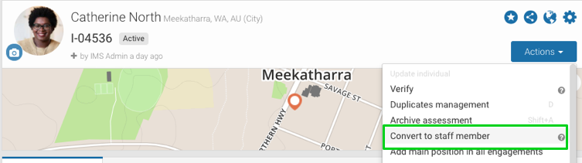

Using distribution lists to bulk add stakeholders
Adding participants to communications helps create relations within the system and allows you and your team to leverage the reporting and sorting options in Borealis.  Using distribution lists, you can add multiple stakeholders all at once, saving time! | Add Participants to a Communication from a Distribution List

Fixing mistakes
Edit a record
Records are the basis of all information available in the system. It is important to be able to consult them and then gain the ability to create, modify and delete or deactivate them.  Individuals, organizations, communications, grievances are examples of records in Borealis. | Work with Records

Revert imports
As a user with rights to import data, you may be hesitant before importing information in Borealis, especially the first time. You may want to do some tests before actually proceeding!  Make yourself comfortable: you have the power to revert an import up to 7 days after performing it, provided that your data was not linked to other records in the meantime. | Revert an import

Merge duplicates
The Stakeholder Merge feature identifies potential duplicates based on name similarities. It also recognizes other information to evaluate the recordings to identify duplicates including nicknames, email, organization, location, address, etc. The tool allows users to merge or reject potential duplicates with just a few clicks to ensure data integrity.  Stakeholders should be merged when more than one record exist in the system that refer to the same stakeholder. This is a data integrity flaw that prevents from proper tracking of interactions with that stakeholder. | Manage and Merge Duplicate Stakeholders  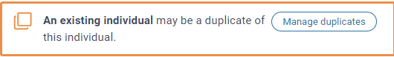

Outlook add-in
Finding stakeholder contact information
Don’t waste time anymore doing back-and-forth between your mailbox and Borealis: Thank to the G-mail or Outlook add-in, you can directly search individuals stored in Borealis from your mailbox!  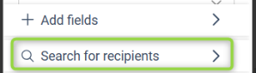 | Search for stakeholders through the Outlook add-in

Sending emails in batches using the add-in
This Borealis Mail Handler lets you mass create email communications in Borealis by forwarding emails in batch to the Borealis Batch email address.  After identifying the emails, you can forward them in batch to create a communication of type 'email' for each one. | Create Multiple Email Communications in Borealis with Outlook

Viewing a communication you previously sent to Borealis
After sending the email to Borealis, you should have received an automated email from the system. Reviewing this email will let you validate whether your email was processed successfully by the system and whether warnings or errors occurred during the process.  However, you may have deleted this email or want to go directly to the record in Borealis to add detail or make edits. You can navigate your way there from your sent items folder in Outlook and using the add-in. | Send a communication to Borealis (Outlook on Desktop)

Analytics Module
Customising widgets in reports
When building a custom report, you may use system widgets or widgets created by your colleagues in the system.  The management and editing options available to you depend on your user profile and report ownership.  It is also important to note that editing a widget will apply the changes made to other reports using this widget. You may want to make changes to the widget that apply only in your report. | Edit Widgets in a Report

Report filters
Borealis Report Filters are a powerful tool to allow easy reporting on many levels. In a nutshell, report filters allow you to create a report with multiple widgets, then to filter all those widgets at once using your new report filters.  This might be useful to you if:  - You are in charge of a team and would like to filter your management report on one staff member at a time for your weekly one-on-one  - You want to browse results between specific date ranges  - You want to narrow a global dashboard to certain individuals, engagement plans or locations | Add Report Filters to your Report

Scheduled reports
Reports allow you to view and share information to better leverage the data in the Borealis application. To improve the process of sharing information, after a report is created, you have the option to define intervals at which point, the scheduled report will be sent to Borealis users. | Setup a Schedule to Send a Report Automatically

Add tooltips for a field (Superusers only)
Getting high quality data relies on all users having the same understanding of what should be recorded in the system. Using tooltips can ensure all users know that is intended to be recorded.  Borealis offers advanced configuration options for managing data dictionaries. By adding descriptions to the values of your data dictionaries, your users can see details on what the meaning of the available options for a given field. | Add Tooltip Values in your Data Dictionaries

