change measurement PLAN
Change Management Toolkit - Template
Phase | 3. Reinforce and evaluate the change
Step | 2. Measure the Change
Revision date | April 17, 2024
Contents
Purpose 1
Identify goals and metrics 1
Set targets 3
Identify data sources 3
Note the frequency of data collection 3
Assign responsibility 4
Change measurement plan 5

Purpose
It’s often said that what gets measured gets done. It’s also true that if you want to know how to assess your change efforts, course correct when necessary and communicate your successes, you’ll need to know what you’re trying to measure in the first place.
This template can help you to define what success looks like for your organization and how you are going to measure it.
Identify goals and metrics
What do you want to achieve by implementing Borealis in your organization?
You may have already identified your primary goals as part of your project planning, but you may want to expand on this by identifying short-, medium- and long-term outcomes.
For example, as you reach the end of the onboarding process, your business analyst will work with you to set adoption goals for your organization. These are shorter-term outcomes that can be observed and measured within 3 months of go-live.
Consider incorporating other aspects of change into your measurement plan. Susan Miller offers a useful framework for measuring change success that emphasizes completion and acceptability, alongside achievement.
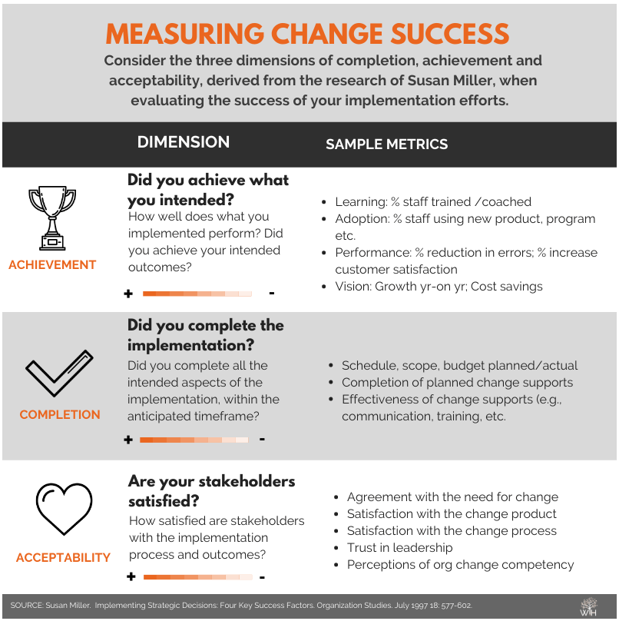
Once you have defined your goals, identify how you are going to measure that change. What indicator(s) when communicated together will paint a picture of the change? Each goal may have one or more metric but best practice is to aim for quality over quantity. Too many measures can muddy the water.
Set targets
Once you have identified your change goals and how you are going to measure the change, define the target for success. For example, if the goal is user adoption and you are going to measure adoption by looking at how often users are logging into the system, you will need to define how many logins in each period constitutes success. Do you want people to log-in every day? Once a week? Once a month?
Consider allowing a range of successful outcomes. Think about defining what is acceptable and what is ideal. There may be a considerable difference between the two targets.
Identify data sources
Once you have your goals and metrics identified, think about where you are going to draw that data from. Is there a data source already in place that you can use? Or will a new data source or collection system need to be established? You may have identified several strong metrics to tell your change success story but if there is no way to collect that data, it won’t do much good.
Borealis itself can provide a lot of data related to adoption goals and quality of stakeholder data. Talk to your business analyst for help setting up a custom report to help pull that key information.
If some of your data is going to come from stakeholder feedback (internal or external), refer to your feedback strategy for data sources.
Note the frequency of data collection
Borealis reports can be pulled at any time, generating real time data for your success reporting. However, other data sources you have identified may only be available quarterly or even annually, depending on how they are collected and where they sit in the organization.
Consider how frequently you are wanting to generate change reporting and how that aligns with data availability.
Assign responsibility
Finally, ensure you have identified who will be responsible for collecting that data so that your measurement plan can be executed on time. Think about who will perform the data analysis, how you are going to share it and with whom.
As you monitor and evaluate the change, you may identify areas that require improvement. Use the Corrective Action Plan template to help address those weaknesses.
Change measurement plan
Goal | Metric | Target | Data source | Frequency of data collection | Responsible
E.g. Improved compliance reporting | Hours to generate compliance reports | 25-35% decrease in time | User timesheets | Quarterly | D. Ackerman
 | Regulator satisfaction with reports | No flagged reports | Regulator report feedback | Monthly | J. Pippen

