Key engagement points in implementation
Change Management Toolkit- Timeline
Phase | 1. Create an environment for change
Step | 2. Engage your leaders
Revision date | April 9, 2024

Purpose
No doubt, you have worked closely with a team of colleagues as part of making the decision to choose Borealis. Now, you are ready to start working with your Borealis Business Analyst and a group of superusers to begin setting up the system to work for you and your organization.
This document is designed to support Project and Change managers to ensure key engagement activities are carried out at the best time during Borealis implementation.

Key engagement and communication activities
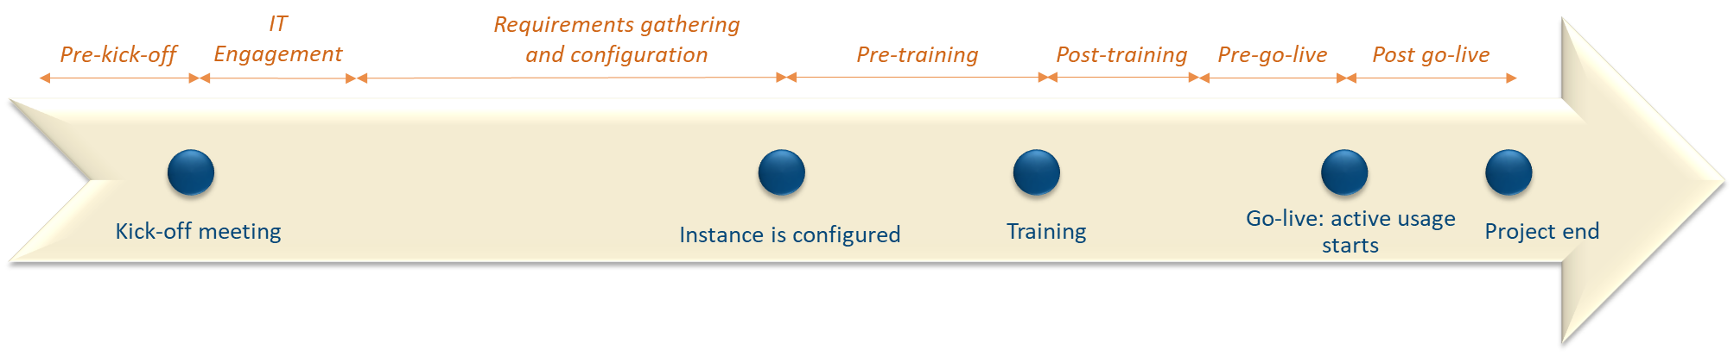
*Note: this timeline is based on the waterfall implementation plan. When using an agile implementation methodology, timelines may shift depending on the context.
Timeline period | Engagement activities | Communication activities
Pre-Kickoff | - Prepare implementation team - identify superusers and define roles | - Pre-launch communication announcing the new stakeholder management system
 | - Determine who will need updates on the project and agree on the frequency and format of updates
 | - Form teams- depending on the size of your organization, it may be a good idea to have teams in each department or on each project where the bulk of your users will sit.
 | - Project plan sign-off by relevant stakeholders
Requirements gathering | - Confirm reporting needs with key internal stakeholders- this will directly inform configuration
IT engagement | - Identify internal IT support and communicate implementation timeline and needs. Refer to the document called “Deploying Borealis - Role of your IT and other departments”
Land Management* | - Engage GIS team to begin organization of land data
Smart Comms* | - Engage communications team to begin discussion of requirements and potential integrations
Configuration | - Consider user testing before go-live to validate configuration set-up | - Consider developing internal user manuals or process documents
Pre-Training | - Consult on training plan - many users can mean scheduling challenges | - Training invitations
 |  | - Build excitement for launch- emphasizing the benefits of the change for the users
Post-Training |  | - Share training materials and collect feedback
Pre-go-live | - Consider hosting some kind of go-live event or running some type of contest for users in the first weeks after go-live to keep people engaged and encourage system use. | - Pre-Launch communication: include details on go-live date and let people know what they can expect to see after that.
Post-go-live | - Provide people a channel where they can get support from their peers and from super users. Some options include:  - A MS Teams or Slack channel where users can post questions to the group in real-time and receive support from superusers  - Internal recognition for champion users
 | - Host 3-month, 6-month and 1-year refresher training. | - Share tips and tricks, system updates and reminders.

