Stakeholder analysis and resistance management plan
Change Management Toolkit - Worksheet
Phase | 2. Communicate and apply the change
Step | 2. Manage Resistance
Revision date | April 8, 2024
Contents
Purpose 1
Step 1- Analyze your stakeholders 2
Stakeholder map 3
Step 2- Plan your engagement approach 4
Suggested approaches 5
Engagement plan 7

Purpose
There are as many reasons that people may be resistant to change as there are people in your organization. The key to managing resistance, is understanding where it is coming from and what is driving it.
You likely have an idea of where your stakeholders (people impacted by, or with the ability to impact, your project) already stand, but it can be helpful to identify where they fall on the spectrum to know how to best engage with them during the project.
This worksheet will help you analyze your stakeholders based on their position on the project and then devise engagement strategies to address resistance.
Step 1- Analyze your stakeholders
Using Block’s Stakeholder Matrix, identify your stakeholder types.
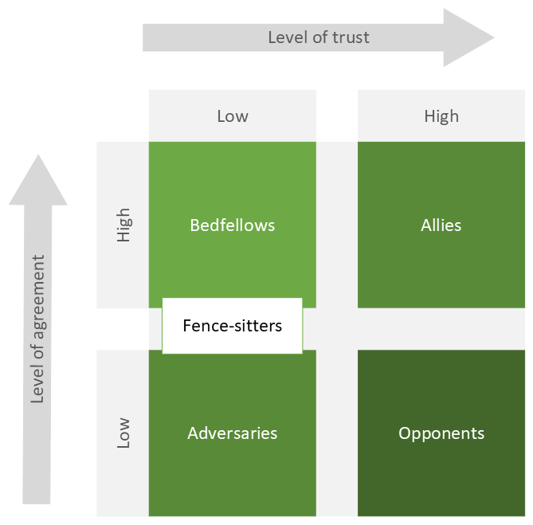
Bedfellows (high agreement, low trust)
- Agree with the project but don’t trust the way the organization does things.
- May express support in one breath and then be critical in another, depending on whom they are talking to.
Adversaries (low agreement, low trust)
- Have a poor relationship with those implementing the change.
- Has concerns about the change and is actively resisting.
Opponents (high trust, low agreement)
- Unlike adversaries, have trust in the organization but don’t think the change is a good idea.
- May provide critical feedback that could improve the project.
Allies (high trust, high agreement)
- Share the change vision and think the project is valuable.
- May have influence over other stakeholders and can be important change champions.
Fence-sitters (low trust, neutral agreement)
- Cautious, non-committal or just unaware of the project.
Stakeholder map
List your Allies

List your Bedfellows

List your Fence-sitters

List your Opponents

List your Adversaries

Step 2- Plan your engagement approach
Now that you have mapped your stakeholders by type, identify how you are going to engage them in a way that addresses any resistance. Think about why they may be resistant to the change. It may be helpful to use this framework to identify the underlying reasons for resistance.
- Level 1- I don’t get it.
  - Not enough information
  - Lack of agreement with the information
  - Confusion about the change
- Level 2- I don’t like it.
  - Emotional response, driven by fear
  - Worry about losing status, losing face or losing security
- Level 3- I don’t like you.
  - Lack of trust in the organization
  - Lack of confidence in leadership
Suggested approaches
Allies
Goal: Cultivate your champions
- Involve them in the project- consider making them a team leader in their department, or a superuser. They’re already on-side, leverage that support!
- Make sure to discuss any of their issues or concerns with the project.
- Ask for their advice and input.
- Engage them in decisions around project implementation.
Bedfellows
Goal: Build trust
- Acknowledge any caution or concerns about the project.
- Ask them how they would like to be involved in the project going forward- consider including them as part of a user testing/acceptance group.
- Provide them with unique opportunities to share their feedback.
Fence-sitters
Goal: Educate and determine their position
- Share the business case and vision for change with them
- Ask directly how they feel about the project
- Emphasize “what’s in it for them”
- Invite them to be more engaged in the project in some way
Opponents
Goal: Build agreement
- Try to understand what is driving their opposition- (what level of resistance are they at?)
- Share the business case and vision for change with them and make sure you understand their precise position.
- Extend a personal invitation for them to get involved with your project in a way that utilizes their skills and knowledge.
- Engage in problem-solving so that you build something together
Adversaries
Goal: Minimize threat to your project
- Understand the potential impact- does this person have a great deal of power or influence in the organization?
- Communicate the business case, vision for change and benefits of the project.
- Acknowledge the lack of trust and your role in the relationship.
- Don’t threaten or demand anything from them.
- Be transparent about what you are going to do and make sure they have as much information as possible about timelines and actions.
- Don’t pressure them to support the project, it will likely result in them digging in their heels even more.
Now, build your engagement plan using the template below.
Engagement plan
Fill out the plan below with the stakeholders you identified above. Indicate their current stakeholder type with a tick in the relevant column.
Stakeholder | Describe their current understanding (including concerns) | Ally | Bed-fellow | Fence-sitter | Opponent | Adversary | Engagement approach  (what steps will you take to change their understanding) | Key messages

